**LOCATION**

Located east of I-95 and just north of Shellman Bluff. **Shown by Appointment Only**

McIntosh County, GA • +/- 181 ACRES • $2,320,323

This tract is located in the heart of Coastal GA where peaceful living, saltwater boating, saltwater fishing, bird watching, and upland hunting adventures abound. Many public access areas to outdoor adventures are available within a short three mile drive. This property is suitable for a large private coastal estate, real estate development, and perhaps a conservation easement.

**McIntosh 181 Tract**

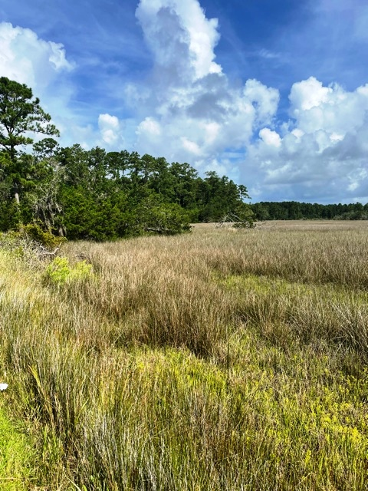

**OPPORTUNITY**

* Fishing at Shellman Bluff
* Boating in the Atlantic Ocean
* Viewing the beauty of St. Catherine’s Island and Blackbeard Island
* Endless options for use and enjoyment

**SITE DATA**

* 7,100 feet of paved road frontage
* 5,200 feet of beautiful marsh views
* Consists of predominately upland soils
* Natural old growth pine stands
* Moss draped Live oaks and other hardwoods

**F. SCOTT BROOKINS**

**FRC LAND CO., LLC**

**REAL ESTATE SALES**



Information on this property is believed reliable but is not warranted or guaranteed.

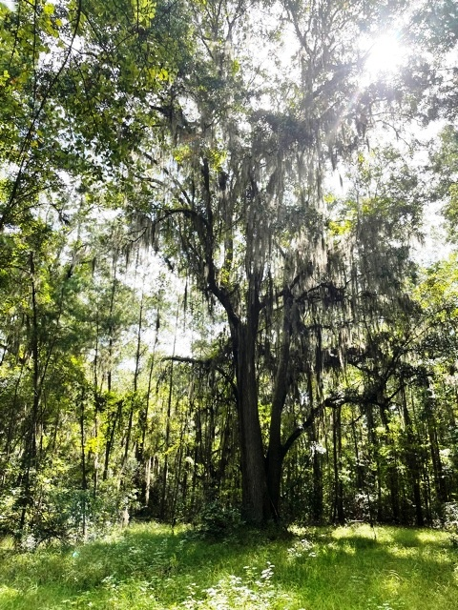

For more information,

478-745-4910

912-682-0268

Scott.brookins@frcemail.com

frclandsales.com