Due Diligence Report

AZ-Apache-107-10-029
Property Details

Owner Name | MCCUBBIN WILLIAM & SHIRLEY
Owner Address | 21 WILLOW FLAT RD SILVER CITY, NM 88061
Assessor’s Parcel Number | 107-10-029
Property Facts

Address | County Road 8233, Concho, AZ 85924
County | Apache
State | AZ
Subdivision/Block/Lot | SHOW LOW PINES UNIT 1 Lot: 29
Legal Description (unofficial) | SHOW LOW PINES UNIT 1 LOT 29
T R S | T-11, R-24, S-12
Parcel Size | 1.16
Number of Parcels | 1
GPS Coordinates | Latitude/Longitude Elevation  Center 34.333805, -109.793000 6794 ft  NW 34.334029, -109.793490 6788 ft  NE 34.333580, -109.793482 6794 ft  SW 34.334038, -109.792487 6788 ft  SE 34.333128, -109.793482 6811 ft
Google Map Link | https://maps.app.goo.gl/4ukv1YvHvuVjaCnT6

Property Record | https://eagleassessor.co.apache.az.us/assessor/taxweb/account.jsp?accountNum=R0015295
Previous Transfer Info | Deed Type WARRANTY DEED  Deed Transfer Date 01/30/2017  Deed Record Location Document Number: 2017-000479

County Website Information

County | https://www.co.apache.az.us/
Assessor | https://www.co.apache.az.us/ | (928) 337-7624
Treasurer | https://www.co.apache.az.us/treasurer/ | (928) 337-7629
Recorder/Clerk | https://www.co.apache.az.us/recorder/ | (928) 337-7515
Planning/Zoning | https://www.co.apache.az.us/community-development/ | (928) 337-7526
GIS Website | https://jt.co.apache.az.us/
Property Tax Information

Assessed Property Value | $585.00
Actual Property Value | $7,000
Back Taxes Owed | $109.39 (Taxes Due: $15.36 - Interest Due: $1.02 - Misc Due: $10.00 - Lien Due: $77.82 - Lien Interest Due: $5.19)
Tax Liens | $77.82
Annual Property Taxes | $15.36
Actual Property Details/Information

Access Road | County Road 8233, County Road 8232
Road Surface | Dirt
Road Maintenance | County
Elevation (ft) | Low: 6788 ft  High: 6811 ft
Flood Zone? | No

Terrain Type | Flat, Plain, Shrubs, Low Vegetation
Closest Highways | US Highway 61, Arizona HWY 60
Closest Major Cities | Show Low, Snowflake, St. Johns
Closest Gas Station | Jiffy Store, Triple R Fuels, 24 Hour Gas & Go
Closest Grocery Store | Jiffy Store, Family Dollar, The Market at St. Johns
Nearby Attractions | Agate Bridge, Agate House, Rainbow Forest Museum, Petrified Forest National Park, Martha’s Butte, Crystal Forest, Jasper Forest, Scorpion and Ant Art Hill, White Mountain Nature Center, Painted Desert Inn, The Teppes, Porter Mountain Outlook, Show Low Card Game Monument, Pintado Point, Show Low City Park, Show Low Lake, Springer Mountain Fire Lookout, Rainbow Lake
County Details

Zoning | Agricultural General
Property Use Code | AG
What Can Be Built? | House
Time Limit To Build? | You need to start the building project within 180 days (6 months) and pass at least one inspection every 6 months to keep the permit open.
What Can You Do On/Near Property | Reside
Camping/Notes | Subject to the provisions of General Provisions. Tent camping on private land is prohibited except in permitted campgrounds. Using an RV for a certain amount of time is allowed with an approved Zoning Permit as long as there is not an existing residence on the property. A single RV may be placed for one time each calendar year for a period not to exceed 30 consecutive days without an RV Dwelling Permit. The RV must be removed at the end of the 30- day period unless an RV Dwelling Permit is obtained. If RV stays greater than 30 days you would need to install a septic.
RVs/Notes | A single RV may be placed for one time each calendar year for a period not to exceed 30 consecutive days without an RV Dwelling Permit. If RV stays greater than 30 days you would need to install a septic.
Mobile Home/Notes | Mobile Homes shall be prohibited in all zone. Manufactured Home as of July 1, 2015 all newly installed Manufactured Homes in Apache County shall meet the following minimum requirements.  A manufactured home cannot be placed on any property until the following are met.  • The Unit must be 15 years old or newer.  • A building permit issued from the correct  Community Development Office.  • Within the city limits of St Johns, Eagar  or Springerville, contact the  Community Development Office of the  respective town  • Anywhere else, contact the Apache  County Community Development  Office (928) 337-7526  Further steps might be required as dictated by the Community Development Office. Different counties have different requirements that must be met, so please check with the County that the Manufactured Home is being moved to.
Water | Would be by Well or Water Haul
Sewer/Septic | Would be by septic
Electric | Novapache works in the area, 928-337-4414. Power in the area
Gas | Propane
Waste | Contact Waste Management at: (800) 796-9696. You can also contact the Environmental Services Division at (928) 337-7607
HOA/Fees | None in the region because it is undeveloped land.

Photos

Nearby Property Bounds | 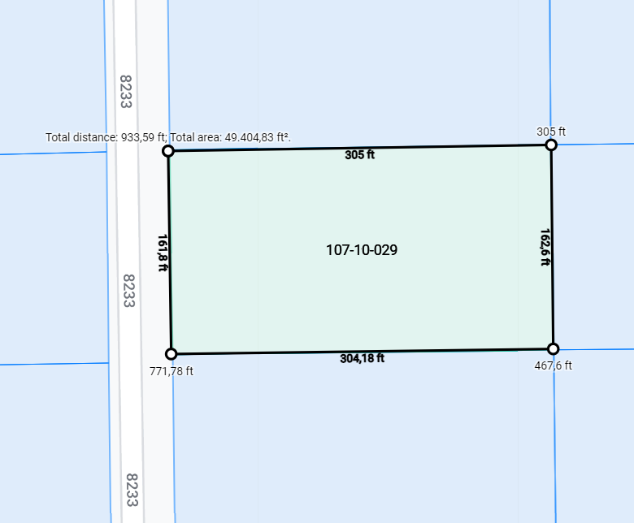
Close Up | 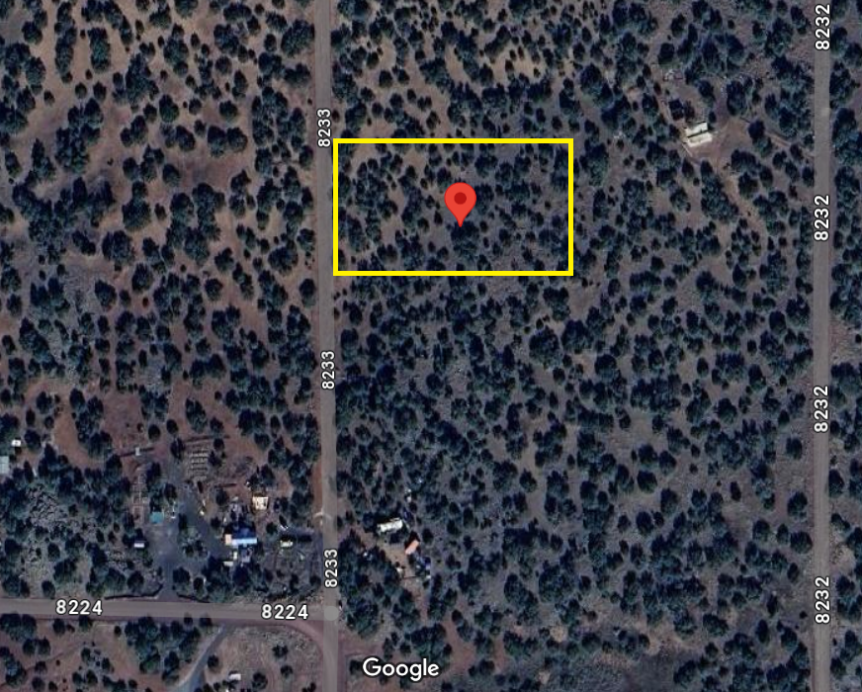
Main Roads Overview | 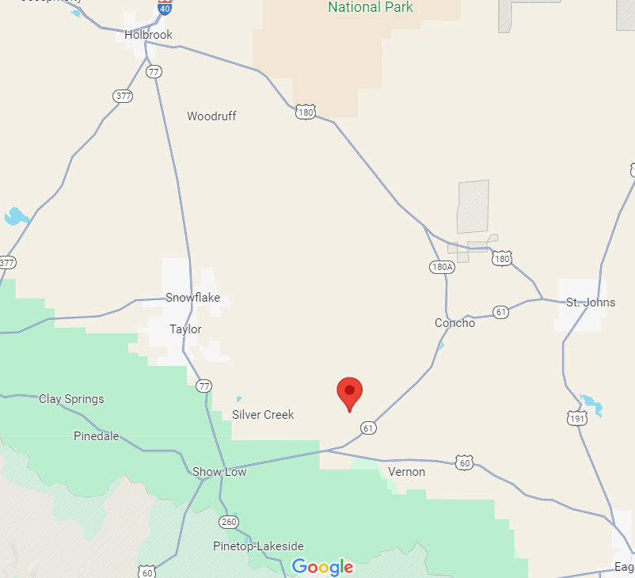
Terrain | 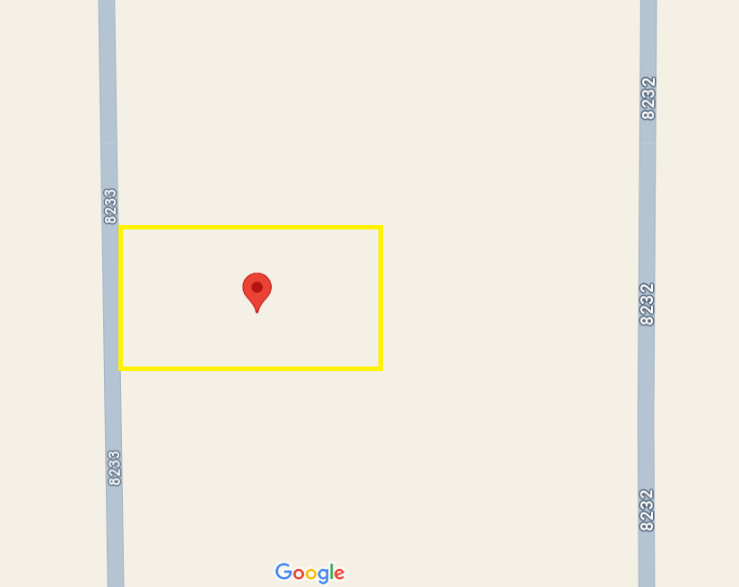

Aerial | 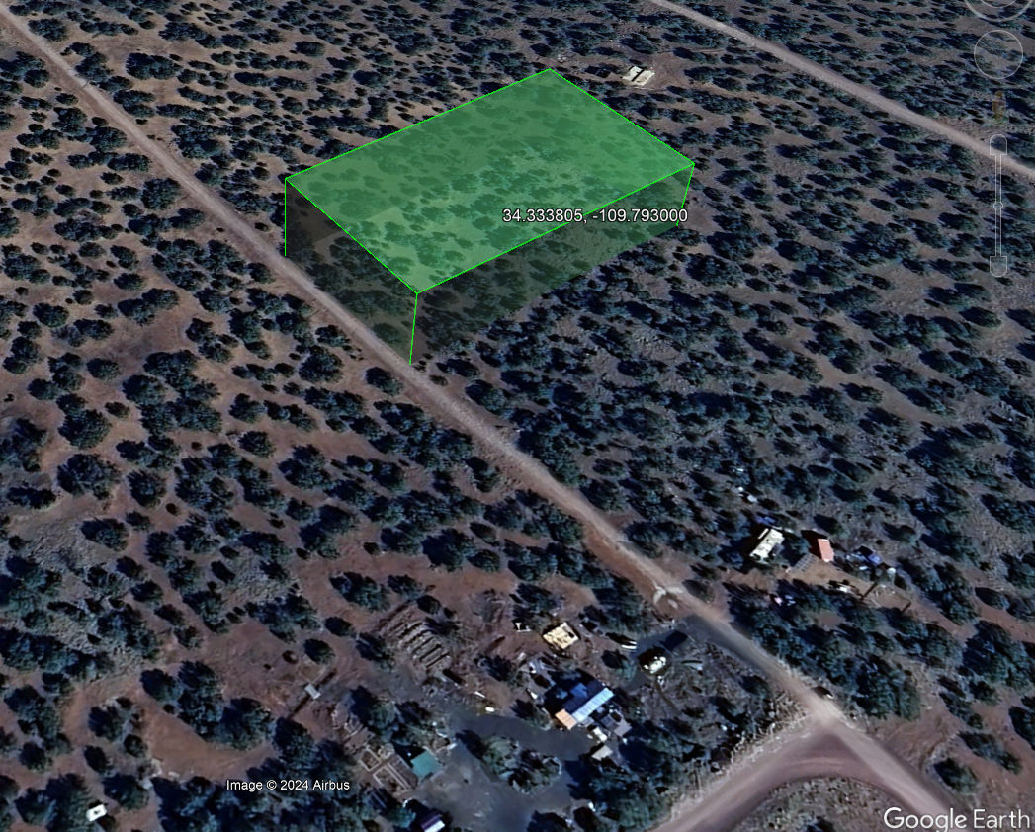
GIS | 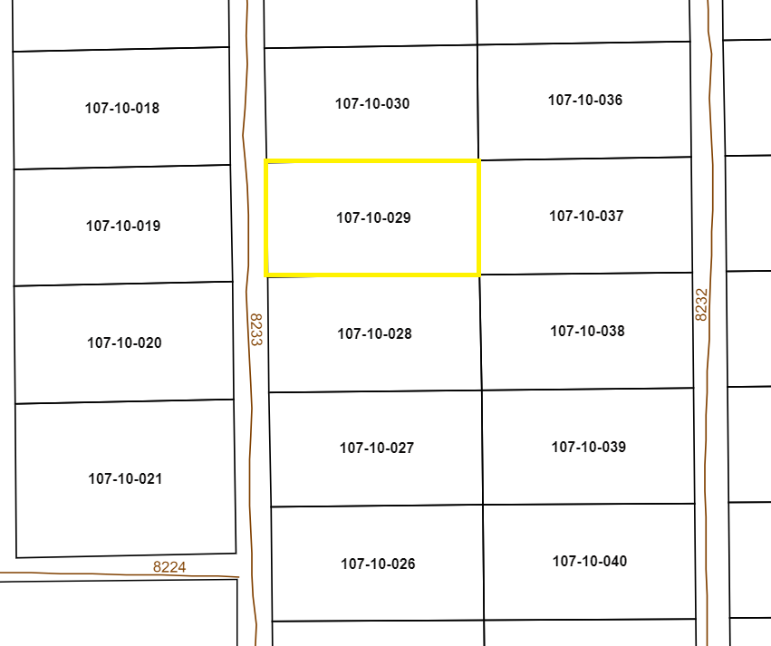

Street | 