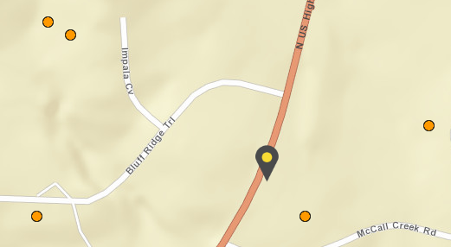
Address: 5548 US Hwy 281 N, Blanco TX 78606
5548 US Hwy 281 N
Blanco, TX 78606
5
4
2
1
3

Surrounding Wells:
Well #1 – Borehole Depth 465 feet, 37 GPM
Well #2 – Borehole Depth 470 feet, 25 GPM
Well #3 – Borehole Depth 410 feet, 15 GPM
Well #4 – Borehole Depth 430 feet, 20 GPM
Well #5 – Borehole Depth 410 feet, 15 GPM

