**Wagoner 180**

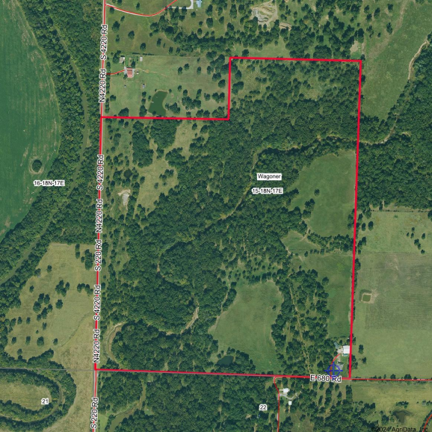

Boundary Center: 36° 2' 10.13, -95° 29' 20.95 **15-18N-17E** 

0ft 640ft 1280ft

**Wagoner County** 

**Oklahoma**

8/9/2024