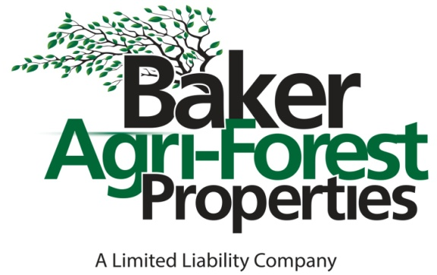

3306 Giamanco Street, Alexandria, LA 71301

P O Box 5624, Alexandria, LA 71307

Phone: 318-473-8751 Fax: 318-473-4045

Website: bakeragproperties.com

Licensed by Louisiana Real Estate Commission, USA

**Property Information Sheet**

DATE: August 20, 2024

ACREAGE: ± 42.15 acres

PRICE: $350,000.00/ $8,303.67 per acre.

LEGAL DESCRIPTION: A ± 42.15 acre tract being located in the SW ¼ of the SE ¼ and the E ½ of the SE ¼ of the SW ¼ of Section 4, T1S-R2W, Rapides Parish, LA.

LOCATION: The property is located in the village limits of McNary, LA and lies west of US 165.

DIRECTIONS: As you enter McNary on US 165 heading south, the property starts at the intersection with Melder Cutoff Road on the right and it fronts US 165 south of Melder Cutoff Road.

GPS COORDINATES: Lat: 36.072

Long: -94.159

ACCESS: The tract has public road frontage on Melder Cutoff Road (+/-700 feet) and US 165 South (+/-1,000’).

CURRENT/POTENTIAL USES: Timber, Nursery, Investment.

MINERALS: Seller will reserve 100% of all mineral rights owned but will waive all surface usage rights in connection with the mineral right reservation.

TOPOGRAPHY: The topography on the property is mostly flat.

SOILS: GrD – Gore very fine sandy loam, 1-3% slopes - 23.3 Acres

KnB – Kolin silt loam, 1-5% slopes - 9.4 Acres

ChB – Cahaba fine sandy loam, 1-3% slopes - 4.9 Acres

MaC – Malbis fine sandy loam, 1-5% slopes - 2.7 Acres

BeB – Beauregard silt loam, 1-3% slopes - 1.85 Acres

TIMBER: The timber consists of old growth pine sawtimber with a lesser amount of hardwood sawtimber and pine/hardwood pulpwood. The timber was inventoried in September, 2023 by Baker Land & Timber Management, Inc. Below are the estimated timber volumes by product class:

Pine Sawtimber - 2,183 Tons

Pine Chip-n-saw - 130 Tons

Pine Pulpwood - 147 Tons

Pine Topwood - 605 Tons

Red Oak Sawtimber - 279 Tons

Misc. Hardwood Sawtimber - 123 Tons

Hardwood Pulpwood - 637 Tons

Note: Timber volume estimates were derived using locally accepted timber cruise methodology and utilization standards. Timber volumes are provided for reference only and are not guaranteed. Timber cruise computation data is available upon request.

IMPROVEMENTS: No improvements.

SITE INSPECTIONS: By appointment only. Please contact Baker Agri-Forest Properties, LLC

** INFORMATION DISSEMINATED ABOVE IS ASSUMED TO BE CORRECT BUT IS NOT GUARENTEED **

NOTE: Baker Agri-Forest Properties, LLC has attempted to present the known facts regarding this property in a fair and accurate manner. However, it should be noted that Baker Agri-Forest Properties, LLC is acting only as a real estate broker in this matter and is not licensed to perform services as a surveyor or attorney, and does not hold itself out as a property inspector, accordingly it cannot be responsible for: any title or survey problems concerning the above described property; any shortages in acreage or land area; the accuracy of the legal description; any defects, hidden or apparent; environmental problems; flooding problems; zoning, building or wetland restrictions, easements, or any other limitations preventing the full use of the above described property; or the suitability of the above described property for any specific purposes or usages.

FOR MORE INFORMATION CALL

ROBERT TASSIN, BRIAN BAIN, DONALD BAKER OR MELANIE BLANCHARD

@ 318-473-8751